UConn ECE 1010 – a rhetorical tool

The Toulmin Model of Argumentation
The Toulmin model asserts that most arguments consist of the following 6 parts:
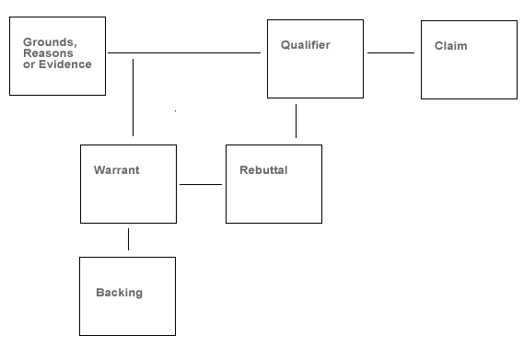
We can also identify 3 other important parts of an argument
Assumptions Counter-examples Implications
Counter-arguments
The Toulmin Model
- Claim: the position or claim being argued for; the conclusion of the argument.
- Grounds: reasons or supporting evidence that bolster the claim.
- Warrant: the principle, provision or chain of reasoning that connects the grounds/reason to the claim.
- Backing: support, justification, reasons to back up the warrant.
- Rebuttal/Reservation: exceptions to the claim; description and rebuttal of counter-examples and counter-arguments.
- Qualification: specification of limits to claim, warrant and backing. The degree of conditionality asserted.
Warrants/General Strategies of Argument
Warrants are chains of reasoning that connect the claim and evidence/reason. A warrant is the principle, provision or chain of reasoning that connects the grounds/reason to the claim. Warrants operate at a higher level of generality than a claim or reason, and they are not normally explicit.
Example: “Needle exchange programs should be abolished [claim] because they only cause more people to use drugs.” [reason]
The unstated warrant is: “when you make risky behavior safer you encourage more people to engage in it.”
There are 6 main argumentative strategies via which the relationship between evidence and claim are often established. They have the acronym “GASCAP.”
- Generalization
- Analogy
- Sign
- Causality
- Authority
- Principle
These strategies are used at various different levels of generality within an argument, and rarely come in neat packages - typically they are interconnected and work in combination.
Common Warrants
1. Argument based on Generalization
A very common form of reasoning. It assumes that what is true of a well chosen sample is likely to hold for a larger group or population, or that certain things consistent with the sample can be inferred of the group/population.
2. Argument based on Analogy
Extrapolating from one situation or event based on the nature and outcome of a similar situation or event. Has links to 'case-based' and precedent-based reasoning used in legal discourse. What is important here is the extent to which relevant similarities can be established between 2 contexts. Are there sufficient, typical, accurate, relevant similarities?
3. Argument via Sign/Clue
The notion that certain types of evidence are symptomatic of some wider principle or outcome. For example, smoke is often considered a sign for fire. Some people think high SAT scores are a sign a person is smart and will do well in college.
4. Causal Argument
Arguing that a given occurrence or event is the result of, or is effected by, factor X. Causal reasoning is the most complex of the different forms of warrant. The big dangers with it are:
- Mixing up correlation with causation
- Falling into the post hoc, ergo propter hoc trap. Closely related to confusing correlation and causation, this involves inferring 'after the fact, therefore because of the fact').
5. Argument from Authority
Does person X or text X constitute an authoritative source on the issue in question? What political, ideological or economic interests does the authority have? Is this the sort of issue in which a significant number of authorities are likely to agree on?
6. Argument from Principle
Locating a principle that is widely regarded as valid and showing that a situation exists in which this principle applies. Evaluation: Is the principle widely accepted? Does it accurately apply to the situation in question? Are there commonly agreed on exceptions? Are there 'rival' principles that lead to a different claim? Are the practical consequences of following the principle sufficiently desirable?
Rebuttals and Main/Faulty/Return Paths
Unlike many forms of writing, academic arguments will often include discussions of possible objections and counterarguments to the position being advanced. Academic arguments typically take place in disciplinary communities in which a variety of competing or divergent positions exist. When preparing to 'speak' to the community by writing an argument, writers are aware of the arguments against which they must build their claims, and of the counterarguments which are likely to emerge. Dealing with counterarguments and objections is thus a key part of the process of building arguments, refining them, interpreting and analyzing them. There are several main reasons for introducing counterarguments and objections.
1. It demonstrates that the author is aware of opposing views, and is not trying to 'sweep them under the table'. It thus is more likely to make the writer's argument seem 'balanced' or 'fair' to readers, and as a consequence be persuasive.
2. It shows that the writer is thinking carefully about the responses of readers, anticipating the objections that many readers may have. Introducing the reader to some of the positions opposed to your own, and showing how you can deal with possible objections can thus work to 'inoculate' the reader against counterarguments.
3. By contrasting one's position with the arguments or alternative hypotheses one is against, one clarifies the position that is being argued for.
When dealing with objections or counterarguments, authors tend to take one of 3 approaches.
- Strategic concession: acknowledgment of some of the merits of a different view. In some cases, this may mean accepting or incorporating some components of an authors' argument, while rejecting other parts of it.
- Refutation: this involves being able to show important weaknesses and shortcomings in an opponent's position that demonstrate that his/her argument ought to be rejected.
- Demonstration of irrelevance: showing that the issue in question is to be understood such that opposing views, while perhaps valid in certain respects, do not in fact meet the criteria of relevance that you believe define the issue.
How well authors produce rebuttals and deal with counter-arguments is an important part of how we evaluate the success of an argument.

